Australian National Saddlehorse Association

Judges Panel, Selection, Validation and Guidelines

REVISED- NOVEMBER, 2023

ANSA Judges Panel
Qualifying for acceptance to ANSA Judges Panel
  - Be a Financial Member of ANSA of a period not less than 12 months.
  - Submission of riding resume and judging experience
  - Detail experience with judging ANSA horses
  - Attend an ANSA Judges clinic
  - Complete an open book test. Candidates are expected to achieve 100% to pass.
Candidates who do not achieve this to be contacted by a member of the Management Committee
  - In accepting an invitation to join the ANSA Judges Panel they agree to act as Ambassador for ANSA, promote the aims and goals of ANSA and adhere to the judging criterion.
  - Judges will be recognised as State or Royal/National
    - Judges will be accepted to General on the criteria above
    - Judges will be nominated to Royal Level by the National Management Committee based
on an assessment but not limited to the following criteria
      - Have achieved success as a competitor, breeder/producer or exhibitor
at State /National/Royal Levels
      - Be a member of other Judges Panels for other major
Breed/Show Societies such as ASHS,AHSA,HHAA. SHA. EA. AQHA etc
      - Have demonstrated experience as a Judge at Royal/National/State Levels
      - Plays an active role in the promotion of ANSA and
Its aims and goals in various activities
  - Judges on the General list may apply for recognition and elevation to Royal /National based of the preceding criteria by writing to the ANSA National Management Committee

- Remaining on Judges Panel
- Reviewed yearly by the management committee
- Agree to remain on panel. A form will be sent with each year with membership renewals inviting judges remain on the Judges List and request they return the form with acceptance of the invitation. It is a privilege to be asked to represent the Society as a judge
- Attend one ANSA Judges Clinic within a 3 yr period.
- Will be a financial member of ANSA
- Panel lists are updates frequently. Any members of the list found to be not financial members will be removed
- Non -Members Judges for a period of more than 11 months are required to apply to be reinstated to the Judges Panel with a completion of Judges Application and the Open Book Test Paper (in order to demonstrate currency) and payment of current membership fee

- Mentor Judges
  - The ANSA National Management Committee may nominate and invite selected Judges to be recognised as ANSA Mentor Judges. Invited Judges have the opportunity to decline the responsibility.
  - The role of the Mentor Judge:
    - Enable shadow Judging appointments for Level 1 Judges seeking to gain more skills
    - Contribute to Judges Clinics
    - Provide support to all Judges on the ANSA Judges Panel in the instance of problem solving
    - Complete and return mentoring assessments after each appointment
  - The number of Mentor Judges in each state will proportionate to the number of Judges on each state’s list.ie
1 per 30 and will NOT be a member of the National Management Committee.
  - Mentor Judges will have a long standing involvement with ANSA, be recognised as a Judge who enjoys a strong and respected reputation with the ANSA Community and is current with competitive and judging practices
  - They WILL be Full Financial Members only

- Associate Members
  - The ANSA National Management Committee may invite recognised Judges to enjoy an Associate Membership for the purposes of Judging only.
  - The objective of this initiative is to add depth and breadth to the range of skills available to the Association while enlisting professional individuals who will act as Ambassadors to promote the aims and goals of ANSA
  - Those invited will be experienced Judges who no longer, or do not produce or compete ANSA horses for ridden or in hand competition and do not maintain full ANSA Membership for that reason.
  - Admittance to Associate Membership
    - Complete Open Book Test Paper, to demonstrate an understanding of ANSA Goals, Objectives and
Judging practices.
    - Submit Judges Application
    - Invitees will be required to attend an ANSA Judges Clinic in the first year of their Association Membership
    - Invitees will be required pay an annual membership fee of $25 ( as set in July, 2017 subject to change) as an administrative fee.
    - Associate Members will not have voting rights but will receive
Newsletters
    - Associate Members may NOT register or compete an ANSA horse in any discipline
    - Full Members who wish to downgrade their membership their to Associate must submit a request in writing to the National Management Committee before the end of the Membership Year

- When do ANSA Judging Criterion and Rules apply?
  - At any dedicated ANSA Feature Show or Event or dedicates ANSA Show Ring
  - Any restricted ANSA Event
  - Where event organisers and programs state ANSA Judging Criterion applies
  - Ruling regarding headwear can be over-ruled by convening show committee
  - Events conducted under Equestrian Australia Rules will over-ride ANSA Rulings

- Aims and Goals of ANSA
  - To promote the breeding and recognise the qualities of the Saddlehorse
  - To further the objectives of the Association and to promote the improvement and popularity of Saddlehorse in Australia and elsewhere
  - To promote in any way whatsoever the interests of breeders and owners of ANSA horses
  - To adopt such means of making known the objects and benefits of the Association as may seem expedient
  - To compile, print and publish whenever considered desirable any registers of, or relating to ANSA horses including foal recordings, transfers or any other ancillary records considered necessary
  - In furtherance of the objects of the Association, to support and assist in the progress and development of any Agricultural show, to promote, competition to award prizes and to make contributions for that purpose.
  - To appoint judges for an maintain a list of persons competent to act as Judges for the Association at any show
whether promoted or sponsored by the Association of otherwise
  - To hold and promote shows, exhibitions or sales of ANSA horses and to offer prizes in respect of competition between ANSA horses or between ANSA horses and other breeds or cross breeds
  - All annual ANSA shows are closed to members and ANSA registered horses only. The programme should cater
for all categories with slight variations to suit localities and with ANSA judges to be given first consideration

- What is an ANSA Horse

Type and Conformation

- Soundness is paramount.
- Strong functional conformation should be evident reflecting good breeding and free from hereditary defects
- There should be no signs of coarseness or commonness.
- Good straight even gait
- Horses must be correct enough structurally to enable them to stay sound for a long productive life under saddle.
- They must have a well proportioned body to produce a comfortable and pleasurable ride.
- Versatility is highly valued and encouraged.

Three ways for a horse to be registered

- Foal recorded – progeny of ANSA Registered horses
- Inspection by Classifier – video or DVD classification by arrangement
- Performance record

For more information pertaining to the classification and registration of ANSA Horses consult the ‘Classification of ANSA Horses’ document.

Judging criterion

- Preference for ANSA Attire including ANSA Saddlecloth
- Conformation first and foremost
- Good calm temperament – bad behaviour e.g. rearing/striking/kicking out will not be accepted.
- An ANSA horse must be a comfortable riding horse
- Must be ridden in a snaffle bit only
- No artificial aids
- The workout to be in both directions at all paces
- Whips are permissible in led classes only should an owner or handler require one for the purposes of effective control – see ruling on whips for acceptable lengths and use.

Best Presented ANSA Horse and Rider
A ridden workout to be judged on a combination of the following:
- Conformation and suitability
- ANSA attire, saddlery and presentation
- Rider’s ability
- Horse’s paces, manners and ability

ANSA Attire
Competitors must wear at Royal, Annual or Feature Shows, and bear weighted judging decisions at all other Shows.
- This is not always practical at all shows hence Judges will acknowledge these situations and demonstrate practical and flexible attitudes in regards to rider’s attire and saddlecloths.
- Ridden ANSA Horses will always be exhibited in snaffle bridle
without whips or spurs.
- Top Hats are not acceptable
Correct Attire for ANSA
- ANSA tie
- ANSA long sleeve shirt
- Approved head wear including felt hats.
Top hats are NOT acceptable. Australian Standard approved helmets
And Stockmen Felt Hats will be accepted by ANSA BUT THE CONVENING Show Society’s rulings on acceptable headwear will take precedence and it is the Competitors responsibility to ascertain which rule applies.
- Juniors must wear an approved standard helmet
- Fawn or light coloured stockman cut trousers or jodhpurs/breeches
- Riding boots may be long or short – gaiters may be used – refer to Classic or Traditional
- V-necked jumper or coat/jacket optional. Colour optional but appropriate to the showring
- ANSA saddle blanket
- Australian or English Saddle - see rulings on Classic and Traditional
- Single Bridle with snaffle bit – Cavesson noseband only.
- No artificial aids
- Riding Gloves are optional

Classic or Traditional?
- Exhibitors should select to present as either Classic or Traditional - not a mixture of both.
- When presenting with an Australian/stock saddle and bridle the riders attire should be stockman’s pants with felt hat or helmet – similarly when presented in English saddle and bridle rider’s attire should be breeches/jodhpurs with approved standard helmet.. The rider may choose between long or short (with or without gaiters) boots.
- Headwear will always be ruled upon by the convening show committee: ie the acceptance of felt hats or velvet caps. It is the competitor’s responsibility to ascertain which rules apply.
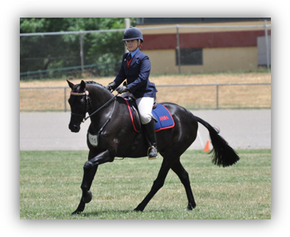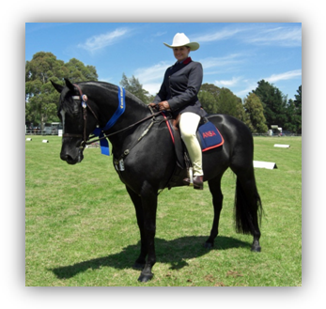

Quick reference guide:
Classic | Traditional
- English Show or dressage style saddle  - Snaffle bridle with cavesson noseband – embellished or ribbon browbands allowed  - ANSA Saddle cloth  - Approved standards helmet  - ANSA blue chambray long sleeved shirt  - ANSA blue tie with logo  - Coats/v-necked jumpers optional  - Fawn or light coloured breeches or jodhpurs  - Long or short boots – short boots with gaiters  - Riding Gloves optional | - Australian/stock saddle – stirrups to be Ox Bow or 4 Bar  - Australian bridle – embellished or ribbon browbands allowed  - Cavesson nosebands permitted  - ANSA Saddlecloth  - Stockman’s breastplate  - Approved standard helmet or Felt Hat  - ANSA blue chambray long sleeved shirt  - ANSA blue tie with logo  - Stockman’s pants with short boots  - Ladies may wear jodhpurs with short boots  - Coats/v-necked jumpers optional  - Riding Gloves optional

Dealing with the incorrectly attired ANSA Horse.
- At a Royal Show or ANSA Feature Show all competitors will present correctly attired otherwise are deemed not eligible for judging
- At many regional or smaller shows competitors will be moving from one ring to another while juggling a multiple of classes requiring gear or clothing changes.
- Practicality and flexibility should be observed however competitors should be given the opportunity to change bridles, remove spurs or flash nosebands and not carry their whip.
- Judges are not to be put in an adversarial position and, if after being asked to change any gear, the rider chooses not to then the Judge will take the incorrect attire into their considerations and show preference for those correctly presented.

8.Etiquette, ethics and professionalism
  - Judges responsibilities to ANSA
    - Understand the aims and goals of ANSA and make sound judging decisions in accordance of those aims and goals
    - Make judging decisions in accordance with the ANSA Judging Criterion
    - Promote ANSA
    - Judges will demonstrate a professional attitude when dealing with Show Societies, Event organisers and ground committees.
    - Attire themselves in a suitable manner. Well presented Judges endorse their own credibility.
    - ANSA considers the Judge entering the Show Ring to be in a place of work or business thus issues pertaining to OH & S should be observed and recommends the following
      - Judges should dress to conditions
      - Sun protective Hats for Ladies and Gents (Fasinators for ladies only if indoors)
      - Dress code for Gents : Judges will include Hat – short or long sleeved shirt, tie, jacket (may be removed
If temperature high) slacks/long pants and enclosed foot wear.
      - Dress code for ladies will include a shade providing Hat, suitable length skirt or slacks/long pants, jacket, top/blouse with sleeves, t enclosed foot wear
  - Interacting with competitors
    - Interaction between judge and competitor should be conducted through the ring steward or ground committee – this includes questions regarding the holding of classes in the instance of clashes between rings.
    - Any competitor with questions arising from judging decisions must address their query to the show/ground committee.
  - Conflict of interest: it is not appropriate for judges to judge:
    - Their own Students or Instructors
    - Family members
    - Business partners or Persons with whom they have had recent business dealings including provision or receipt of services, purchased a horse from or sold a horse to as well as horses that they recently sold, etc - within a period of not less than 6 months.
    - Horses in training or have been in training with that judge, on behalf of its owners – within a period of not less than 6 months
    - Persons providing accommodation for judges before an event at which they are scheduled to compete under that judge.
    - It is always the competitor’s responsibility to find out who the judge is and not present for competition if there is a conflict of interest.
  - Frequency
    - Judges may not judge ANSA Classes at more than one Royal, National Titles/Championship or A Grade ANSA Show in the same state for a period of two calendar years following.
    - For example: if engaged to judge ANSA Classes at Sydney Royal in 2010, the Judge would not be eligible to accept an appointment to judge ANSA Classes at Bathurst Royal until 2013. As in: excluded from judging at that level in that state for 2 calendar years – in this example 2011 & 2012.
    - This does NOT preclude Judges from accepting appointments at this level in other states during that time.
    - When engaged to judge at any Royal, National Titles/Championship or A Grade ANSA Show a Judge may not judge ANY ANSA classes at ANY show in ANY State for a period of 3 months beforehand.
    - ANSA acknowledges the difficulties Show Societies can experience in securing Judges for their Shows: however Judges will consider the appropriateness and ethical implications of appointments occurring frequently and often, particularly within a specific region or district with specific regard to the Judging of ANSA Classes. ANSA Judges, in many cases, are also appointed to a number of other Judging Panels and are strongly encouraged to exercise diversity in their appointments.

- Setting workouts for the ANSA horse
  - Workouts should be formulated to demonstrate qualities identified as desirable by the Judging Criterion specifically the first three points relating to conformation, manners and paces.
  - Conformation will impact on the horse’s ability to move freely – perceived faults can affect the straightness of his action or his ability to engage.
  - The ANSA horse is expected to demonstrate calm and controlled manners; under saddle and in-hand.
  - Paces must be free, flowing and straight in their action.
  - Setting individual workout which includes 2 or more changes of direction with lengthening of trot and/or canter will demonstrate responsiveness and submission to the aids ie: freely forward while light to hand and leg.
    - Working the Best Presented Candidate: as detailed in the Judging Criterion the workout should be designed to allow the horse and rider the ability to demonstrate desirable qualities. In this class the judge will be considering the overall package of horse, rider, presentation and how well they work together.
    - Working the Ridden ANSA Horse: workouts will generally include walk, trot and canter in each direction and may request a lengthening of trot and/ canter. Changes of lead will usually be through the walk or trot – flying changes are seldom asked for however if the rider is given the option of choosing their change of lead and the flying change is offered, then the change should be assessed as performed.
    - Working the Working ANSA Horse: each pace should be demonstrated in each direction but might include lengthened paces, flying changes, haunch turns or rollback and fast work.
      - All Fast Work will be ‘Out Of Seat’
      - Fast Work will include Flying Changes.
  - In the interests of safety The ANSA Management Committee recommends that in setting workouts Judges should
    - always take into account the quality and size of the workout area to be used
    - pay consideration to the ‘level’ of the show ie: a Royal show workout can be expected to be more demanding to that of a smaller regional show.

Conformation of the Saddle Horse
  - Judges should always assess the ANSA horse specifically as a saddle horse or as breeding stock for the purpose of producing saddle horses.
  - While the registry contains everything from Andalusians to Walers, and each breed with its own standard, it is important to remember to return to the ANSA Judging Criterion to assess the preferred qualities in the ANSA Horse.
  - It is also important to explore the concept that a judge will seldom have a horse presented that is 100% ‘perfect’ therefore a Judge will have to assess conformational faults and the implications on the working life of the horse. This may also include weighing the faults against each other.
  - Hence it is expected that an ANSA Judge will possess and cultivate a good working knowledge of conformation and its effects on the saddle horse.
  - Judges are expected to have their own opinions and views as to what THEY expect in a quality saddle horse.

- Equipment in ANSA Competition.
  - Ribbon and embellished browbands are suitable for the ANSA Show Ring whether in a Classic or Traditional presentation.
    - With the introduction of Hunter Classes to the National Titles Program it is necessary to note that all Hunter Horses exhibited at an ANSA National or State Show will wear a PLAIN UNADORNED Browbands in accordance with acceptable Hunter Horse presentation.
  - Bitting – snaffles are the only acceptable bit in ANSA competition.
    - For the purposes of the ANSA show ring and restricted ANSA Competition a snaffle bit is described as a jointed bit and the types of bits acceptable include eggbutt or loose ring snaffles.
    - Snaffle bits such as a ‘KK’ with an extra piece added to the middle of the bit to create two joints in the mouthpiece are also acceptable.
    - Snaffle bits with cheeks such as Fulmer or Tom Thumb are acceptable.
    - Mullen mouth snaffles maybe accepted.
    - At no time will twisted wire or gag bits be accepted.
    - Chains thru the mouth are PROHIBITED.
    - Sweet iron bits may be used.
    - Bits must be constructed of just one metal through the mouth ie: no rollers or bands.
    - In the interests of safety and for the purposes of control Rearing Bits used in conjunction with a bridle may be used when showing horses in hand should a handler/owner deem it as necessary. MUST be clipped to noseband under the jaw.
    - It is expected that when using a snaffle bit a single rein will be used.
    - Bitting rules in accordance with Equestrian Australia will apply for events conducted under Equestrian Australia rules ie: open or restricted dressage or eventing.
    - Bridles with double bits/Weymouth or double sets of reins will not be considered as correctly attired when presented for ANSA Competition - either Led or Ridden Classes.
  - Headwear is clearly stated in the judging criterion.
    - Felt hats and approved standards helmets are appropriate when horse is presented in Traditional Attire with Australian saddle and bridle and rider is also attired in stockman’s pants without or with a jacket or coat. Ladies in an Australian/stock saddle may wear jodhpurs with short boots in place of trousers.
    - Juniors (under the age of 18 yrs) must wear approved standard head gear
    - Top hats are never acceptable in the ANSA Ring
    - Approved helmets are appropriate to a horse presented in an English saddle and bridle.
  - The Australian National Saddlehorse Association classifies the following items as artificial aids and therefore not acceptable in the ANSA Show Ring or in ANSA Restricted Competition.
    - Whips and hacking canes (see points e.i. & e.ii. below for exceptions to rule)
    - Spurs
    - Martingales
    - Flash or Hanoverian nosebands
  - Exceptions to the rules:
    - Whips – a stock whip may be required in a Working ANSA Horse workout however this should be stated in Event Programs as to whether the class will be worked with the whip.
    - Whips no longer than 75 cm including tassel or flapper are appropriate for handlers or owners who deem it necessary for purposes of control only. ; hence the whip is prohibited from being used to enhance the workout or in the ‘standing-up’ of horses.
    - Stockman’s Breastplate is appropriate on a horse presented in Australian attire but NO rings.
    - A number holder breastplate is appropriate at shows where exhibit numbers are distributed/required.
    - Dressage whips are allowable in dressage competitions, open or restricted, when run in accordance with Equestrian Australia rules.
    - Bitting rules in accordance with Equestrian Australia will apply for events conducted under Equestrian Australia rules ie: open or restricted dressage or eventing.
    - Spurs rules in accordance with Equestrian Australia will apply for events conducted under Equestrian Australia rules ie: open or restricted dressage or eventing.
    - Boots, wraps and bandages are allowed when competing in such events as Yarding, Campdrafting, Eventing and Showjumping.

- Registration and Membership – to be eligible for ANSA Competition and Awards:
  - Horses presenting for competition will be registered with ANSA from the age of 2yrs or Foal Recorded Youngstock.
  - Owners must be financial members of ANSA.
  - All Riders and Handlers in ANSA Classes at Royal; Championships; State Titles – ANSA run Feature Shows, need to be financial members at the time of the event leaders at Agricultural shows are not included

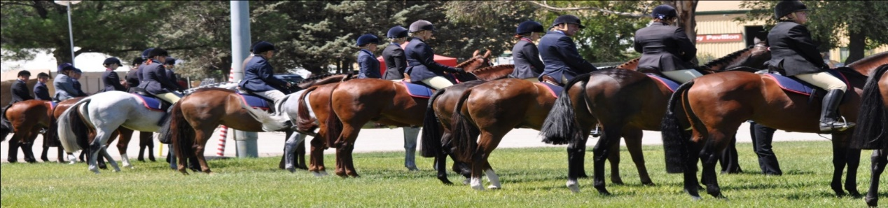

Appendix 1: Working ANSA Horse – no whip
Example of a suitable pattern
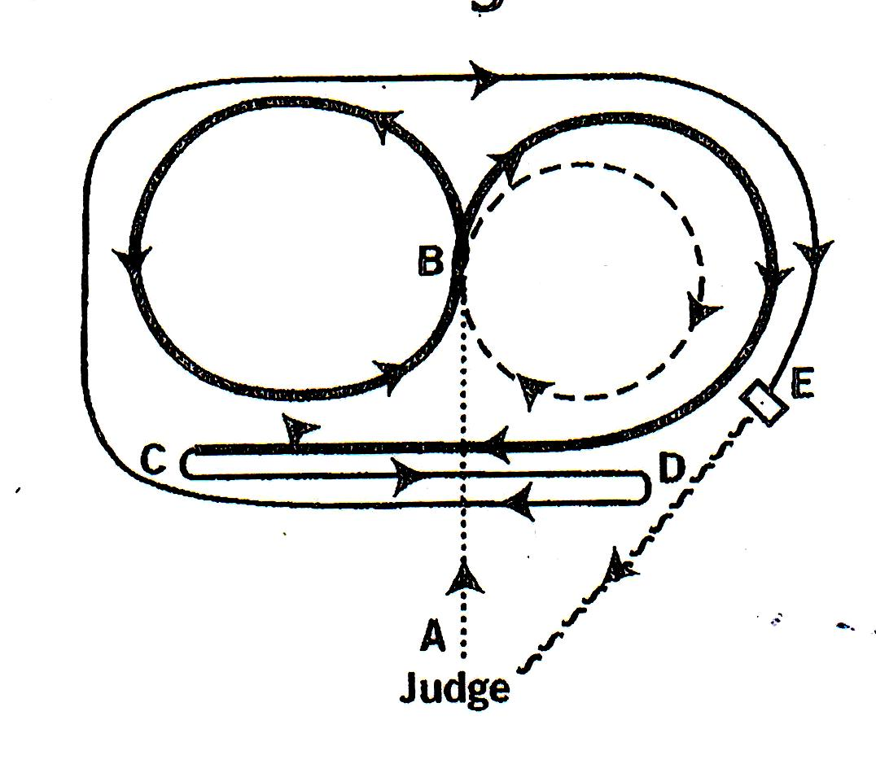
- Present to Judge. From A Trot to B and Trot circle to the right
- At B Hand Gallop and circle left
- At B Flying Change and Hand Gallop right to C
- At C Stop, haunch turn left and canter to D
- At D Stop, haunch turn right
- Continue at Canter right around to E
- At E Stop, Settle and Walk back to Judge on a loose rein

Clarification of Terms
Hand Gallop – a controlled four beat pace,not a fast gallop. Rider to be out of the seat.
Flying Change – is a change of leads at canter cleanly and calmly through a single stride
Stop – horse comes to an immediate stop, elevating slightly in the forequarters to engage the hindquarters before coming to a controlled and complete stop within a short distance.
Halt – through the transitions/paces.
Roll Back – horse Stops with hind legs engaged and under, then turns 180 degrees back over the hocks and moves out on the SAME line in which it entered. Must only be asked for on a suitable surface ie: ploughed, harrowed or sand
Haunch Turn – horse does not stop, takes most of its weight on the inside hind leg to form a pivot, always performed towards the judges position, is a continuous movement and travels in the return direction on a PARALELL line to which it entered.
Settle – stand still and relax

